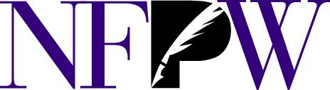
National Federation of Press Women, Inc.
140B Purcellville Gateway Dr., Suite 120, Purcellville, VA 20132 · (571) 295-5900 ·info@nfpw.org · www.nfpw.org

FOR IMMEDIATE RELEASE

June 24, 2023

Media Contacts:
Teri Ehresman, NFPW National Contest Director (islandpark723@gmail.com; 208-521-5171)
Cate Langley, NFPW Executive Director (info@nfpw.org; 571-295-5900)
More information: www.nfpw.org

A list of all winners: https://www.nfpw.org/assets/docs/2023/2023%20Professional%20Contest%20Ceremony.pdf

PRESS RELEASE
For immediate release
National Federation of Press Women announces national award winners
The National Federation of Press Women announces the following is an award recipient during the 2023 NFPW Communications Contest Awards Banquet Saturday, June 24, 2023, during the organization’s annual Communications Conference in Cincinnati, Ohio.

Name: ___________________________________________________________________
Title: _____________________________________________________________________
Home locality: ______________________________________________________________
Category: __________________________________________________________________

NFPW is a nationwide organization of women and men pursuing careers across the communications spectrum, including print and electronic journalism, freelancing, new media, books, public relations, marketing, graphic design, photography, advertising, radio and television.
Recipients from across the country were honored for excellence in communications during an awards ceremony in Cincinnati, Ohio. A distinguished group of professional journalists, communications specialists, and educators judged nearly 2,000 entries in a wide variety of categories. Only first-place winning entries at the state level are eligible to enter the national contest. All entries were published or broadcast between Jan. 1, 2022, and Dec. 31, 2022.

